**DISNEY STORE**



**SPICE Release 8.3.5 (China)**

**User Acceptance Testing**

**TABLE OF CONTENTS**

1.1 Enhancement Description 3

1.2 Revision History 3

1.3 Document References 3

2. Overview 3

2.1 Introduction 3

3. AREAS UNDERGOING CHANGE IN 8.3.5. 4

3.1 New domain-specific "feature switches" 4

3.1.1 Testing of “Feature Switches” 5

3.2 New local language (Chinese) description 5

3.3 Date Formats 5

4. Tests 7

4.1 List of tests 7

4.2 Test : Item Management – Add Item 8

4.3 Test : Item Management – Change Item 13

4.4 Test : APP – Add New 15

4.5 Test : APP – Modify 16

4.6 Test : Purchase Orders – Add New 17

4.7 Test : Purchase Orders – Modify 21

4.8 Test : Purchase Orders – Main Window 24

4.9 Test : Purchase Orders – Creation (multi hits) 26

4.10 Test : Purchase Orders – Creation (Drop Ship Single) 29

4.11 Test : Purchase Orders – Creation (Drop Ship Matrix) 32

4.12 Test : Purchase Orders – Submit for Approval 36

4.13 Test : Purchase Orders – Stage Set Dates 38

4.14 Test : EAS – Work with Approver Requests 40

4.15 Test : EAS – Work with Submitted Requests 44

5. Appendix 46

5.1 Feature switches within the different functional areas of the SPICE system 46

5.2 Spice screen changes 47

5.2.1 Add Item screen 47

5.2.2 Change Item screen 48

5.2.3 Add Assorted Pre-Pack (APP) screen 48

5.2.4 Change Assorted Pre-Pack (APP) screen 48

5.2.5 EAS Approve/Reject screen 49

Feature Enhancement Information

## Enhancement Description

|  |  |
| --- | --- |
| **Title:** | **SPICE Release 8.3.5 (China) – User Acceptance Testing** |
| **Author:** | **John Brown** |

## Revision History

|  |  |  |
| --- | --- | --- |
| **Date** | **Author** | **Action** |
| 22/09/2011 | John Brown | Initial Draft |

## Document References

|  |  |
| --- | --- |
| **Document Name** | **Author** |
| China Changes 11 12 13 Functional Design v1 0.docx | Chris Price |

# Overview

## Introduction

A new version of SPICE, version 8.3.5, is being made available which will be used for new markets in China (Domain = APAC). China will initially consist of two markets, Hong Kong (HK) and Peoples Republic of China (PC). The functional requirements have been outlined in a separate document (see the external document references section). This document will outline what needs to be tested for the release, and provide the tests that need to be performed.

# AREAS UNDERGOING CHANGE IN 8.3.5.

The following are new or areas undergoing changes in SPICE 8.3.5

* New domain-specific "feature switches"
* New Chinese language description
* Date formats

## New domain-specific "feature switches"

Differences in functionality between the domains (previously only EMEA and SWNA) are being provided as feature switches, so that these features can be switched on or off in the various domains without altering the program. These differences were previously features that were "hard-coded" into SPICE. The switches might cause various visual elements to appear, disappear, be enabled or disabled depending on the setting. An example of this is VAT. Since VAT is applicable in China and the UK, but not in North America, fields which hold VAT codes in SPICE will not be visible when logged into the SWNA system.

A full list of the feature switches are displayed in **Table 1**. The main functional areas of SPICE are (1) Item Management, (2) Purchase Order Management, (3) Assorted Pre-Packs (APPs) and (4) the Electronic Approval System (EAS). The table in Appendix 5.1 shows which of these areas these switches are applicable to.

*Table 1: Domain-specific settings and "feature switches"*

|  |  |  |  |  |
| --- | --- | --- | --- | --- |
| **Domain Feature** | **Possible Value** | **SWNA (current)** | **EMEA (current)** | **TDSCN (future)** |
|  |  |  |  |  |
| **Local Language?**  The local language for the domain e.g. ‘Chinese’ for China.  If this is not English, the local language item description field will be enabled. | [language] | English | English | Chinese |
| **Is VAT Required?**  No = Item/Size VAT column not displayed  Yes = Item/Size VAT column displayed | Yes/No | No | Yes | Yes |
| **Are Stage Set Dates Changeable?**  No = Stage set dates are editable on purchase orders.  Yes = Stage set dates are NOT editable on purchase orders. | Yes/No | Yes | No | Yes |
| **Is Landing Factor Required For Road Delivery?**  No = LF disabled (greyed out) when road (ROD) is selected.  Yes = LF enabled when road (ROD) is selected, allowing a landing factor to be input. | Yes/No | Yes | No | Yes |
| **Is Style Number Input Required?**  No = A style number is automatically generated.  Yes = Manual input of style number required. | Yes/No | Yes | No | Yes |
| **Is Promo Code Mandatory?**  No = Promo Code input NOT required.  Yes = Promo Code input required. | Yes/No | Yes | No | Yes |
| **Is Composition Code Editable?**  No = Composition code on APPs / Items NOT editable  Yes = Composition code on APPs / Items editable | Yes/No | No | Yes | No |
| **Is Commodity Code Editable?**  No = Commodity code on APPs / Items NOT editable  Yes = Commodity code on APPs / Items editable | Yes/No | No | Yes | No |
| **Pre-Select All Markets?**  No = Manually select markets for new items / APPs.  Yes = Automatically select all markets for new items / APPs. | Yes/No | Yes | No | Yes |
| **ShowListPrice**  No = Market list price column not displayed  Yes = Market list price column displayed (needed for ECOM channels only) | Yes/No | No | Yes | No |
| **Allow UPC Input?**  No = Allow input of Vendor UPC for market sizes.  Yes = No input of Vendor UPC for market sizes. | Yes/No | Yes | No | Yes |
| **Display PO Hits Cancel Date With Day Format?**  No = Do not display the day of the week.  Yes = Display the cancel date (on PO Hits form) with the day of the week.. | Yes/No | Yes | No | Yes |
| **Days Between Ship Date And Cancel Date?**  No = Allow input of Vendor UPC for market sizes.  Yes = No input of Vendor UPC for market sizes. | [0..100] | 6 | 0 | 6 |

### Testing of “Feature Switches”

Testing of these features within SPICE for China, should check that the features within the environment comply with the settings shown in *Table 1* in the TDSCN column (settings for the China environment).

## New local language (Chinese) description

Several screens in SPICE will now have an item description field to hold the non-English local language equivalent (i.e. Chinese) for the long item description. Entry of the Chinese description in version 8.3.4 will be available for adding and modification of new items and APPS. See Appendix 5.2 for screenshots of all of the screens in SPICE that will contain the new local language item description field.

## Date Formats

Date formats have been made configurable within the system to allow for the differences between domains through the use of a configuration file. *Table 3* below shows the general date format used in the three domains. Date formats within SPICE adhere to the general formats, with slight variance depending on the date field. *Table 4* shows how date formats are setup in SPICE. The following dates should be tested for conformity.

Item Management:

* All date pickers (date calendars)

Purchase Orders:

* Order date
* Cancel date
* Ship date
* Anticipate date

|  |  |
| --- | --- |
| **Spice Domain** | **Date Format** |
| EMEA | dd/mm/yyyy |
| SWNA | mm/dd/yyyy |
| APAC | yyyy/mm/dd |

*Table 3: SPICE domains - date formats*

|  |  |  |
| --- | --- | --- |
| **Spice Domain** | **Date field** | **Date Format** |
| EMEA | All Date pickers | dd/MMM/yyyy |
|  | PO Cancel Date | d MMMM yyyy |
|  | PO Ship Date | d MMMM yyyy |
|  | PO Anticipate Date | d MMMM yyyy |
|  | PO Order Date | d MMMM yyyy |
| SWNA | All Date pickers | MM/dd/yyyy |
|  | PO Cancel Date | MMMM d, yyyy |
|  | PO Ship Date | MMMM d, yyyy |
|  | PO Anticipate Date | MMMM d, yyyy |
|  | PO Order Date | MMMM d, yyyy |
| APAC | All Date pickers | yyyy/MM/dd |
|  | PO Cancel Date | yyyy, MMMM d |
|  | PO Ship Date | yyyy, MMMM d |
|  | PO Anticipate Date | yyyy, MMMM d |
|  | PO Order Date | yyyy, MMMM d |

*Table 3: SPICE - date format configuration*

# Tests

## List of tests

* Test: Item Management – Add Item
* Test: Item Management – Change Item
* Test : APP – Add New
* Test : APP – Modify
* Test : Purchase Orders – Add New
* Test : Purchase Orders – Modify
* Test : Purchase Orders – Main Window
* Test : Purchase Orders – Creation (multi hits)
* Test : Purchase Orders – Creation (Drop Ship Single)
* Test : Purchase Orders – Creation (Drop Ship Matrix)
* Test : Purchase Orders – Submit for Approval
* Test : Purchase Orders – Stage Set Dates
* Test : EAS – Work with Approver Requests
* Test : EAS – Work with Submitted Requests

## Test : Item Management – Add Item

|  |  |  |
| --- | --- | --- |
| Name | Date | Pass/Fail |
|  |  |  |

|  |  |  |  |  |  |
| --- | --- | --- | --- | --- | --- |
| **Seq** | **Instructions** | **Expected Results** | **Pass/Fail** | **Comments** | **Bug Ref** |
|  | Click applications |  |  |  |  |
|  | Click Spice, item management |  |  |  |  |
|  | Click item selection | Item selection window will open |  |  |  |
|  | Click ‘add’ | Market selection box will open |  |  |  |
| 1 | Tick select box next to country/countries that the item is to be defined in – in addition to the master market. | A tick will appear in each country box |  |  |  |
| 2 | Alternatively click select all. | All markets will be selected. |  |  |  |
| 3 | Click on an already selected box | The country will be unselected. |  |  |  |
| 4 | Click unselect all | All countries will be unselected, except for the Master market |  |  |  |
| 5 | Click help | It displays the SPICE User Manual from the SPICE online! website. |  |  |  |
| 6 | Click Cancel | Screen should close |  |  |  |
| 7 | Click add | The market selection window will open |  |  |  |
| 8 | Select the country/ies for the item to be defined in | This will display a tick in the countries selected |  |  |  |
| 9 | Click next | Add item Screen will appear |  |  |  |
| 10 | Type in class number in class box | This will display the class in the field |  | *[Note: Please fill in the test information entered here.]* |  |
| 11 | Click magnifying glass | A list of classes will appear |  |  |  |
| 12 | Double click a class | It will appear in the class field |  |  |  |
| 13 | Clear the class field |  |  |  |  |
| 14 | Click on the magnifying glass next to the class field | A list of classes will appear |  |  |  |
| 15 | Click on the ‘class description’ | This will alphabetise the class list |  |  |  |
| 16 | Type in a class description in the field and click search | This will bring up the classes relevant to your search. |  |  |  |
| 17 | Double click the correct class | This will appear in the class field in the previous window |  |  |  |
| 18 | Click magnifying glass next to vendor | A list of vendors will appear |  |  |  |
| 19 | Double click a vendor | It will appear in the vendor field |  |  |  |
| 20 | Clear the vendor field |  |  |  |  |
| 21 | Click on the magnifying glass next to the vendor field | A list of vendor will appear |  |  |  |
| 22 | Click on the ‘vendor name’ | This will alphabetise the vendor list |  |  |  |
| 23 | Type in a vendor name in the field and click search | This will bring up the vendors relevant to your search. |  |  |  |
| 24 | Double click the correct vendor | This will appear in the vendor field in the previous window |  |  |  |
| 25 | Enter the Style number (if not automatically generated). |  |  |  |  |
| 26 | Type in colour code  in colour code box or  Click magnifying glass. | If magnifying glass is clicked a list of colour codes will appear. |  |  |  |
| 27 | Double click the colour code | This will appear in the colour field |  |  |  |
| 28 | Type in subclass number or click on magnifying glass. | If magnifying glass is clicked on all subclasses will appear |  |  |  |
| 29 | Double click a subclass | The subclass will appear in the field |  |  |  |
| 30 | Type in a long description  (in English) |  |  |  |  |
| 31 | Type in a long description  (in Chinese) |  |  |  |  |
| 32 | Type in a short description. |  |  |  |  |
| 33 | Type a vendor style |  |  |  |  |
| 34 | Import/Domestic should automatically be selected depending on the vendor requirements. | Check this has happened |  |  |  |
| 35 | Click on ‘developed by’ drop down arrow. | List of options should appear. |  |  |  |
| 36 | Selected an option of development | The selected option will appear in the field |  |  |  |
| 37 | Enter composition code or click on magnifying glass. | If magnifying glass is selected composition code search window will appear |  |  |  |
| 38 | Double click a composition code | The composition code will appear in the field |  |  |  |
| 39 | Enter commodity code or click on magnifying glass. | If magnifying glass is selected commodity code search window will appear |  |  |  |
| 40 | Double click a commodity code | The commodity code will appear in the field |  |  |  |
| 41 | Enter country of origin or click on magnifying glass. | If magnifying glass is selected country of origin search window will appear |  |  |  |
| 42 | Enter character code or click on magnifying glass. | If magnifying glass is selected character code search window will appear |  |  |  |
| 43 | Enter season code or click on magnifying glass. | If magnifying glass is selected season code search window will appear |  |  |  |
| 44 | Click on case pack type drop down arrow | Case pack options will appear. |  |  |  |
| 45 | click case pack type option required. | Case pack type will appear in the field |  |  |  |
| 46 | W,H,L,W | Many will default depending on selected case pack type. |  |  |  |
| 47 | If W,H,L,W do not default enter carton dimensions manually. |  |  |  |  |
| 48 | Enter case pack quantity. |  |  |  |  |
| 49 | Enter distro/inner quantity. | Inner/distro must be a multiple of case pack quantity. |  |  |  |
| 50 | Enter vendor cost this is defaulted to master currency. |  |  |  |  |
| 51 | Enter retail price, this is defaulted to master currency. |  |  |  |  |
|  | Select Selling Channel |  |  |  |  |
| 52 | Click next | Item market prices screen appears |  |  |  |
|  | 53 – 55 only applicable if ECOM selling channel selected. Skip otherwise. |  |  |  |  |
| 53 | Enter required information on ECOM Item Setup screen. |  |  |  |  |
| 54 | On the ECOM Item Setup screen, check all the date formats. |  |  |  |  |
| 55 | Click next. |  |  |  |  |
|  | 56 – 59 only applicable if a SIZED item being created. Skip otherwise. |  |  |  |  |
| 56 | Select the Size groups. |  |  |  |  |
| 57 | Click next. |  |  |  |  |
| 58 | Select all sizes on Item Size screen. |  |  |  |  |
| 59 | Click next. |  |  |  |  |
| 60 | Manually over type retail price if required. |  |  |  |  |
| 61 | Click finish | Item has been written message should appear. |  |  |  |

## Test : Item Management – Change Item

|  |  |  |
| --- | --- | --- |
| Name | Date | Pass/Fail |
|  |  |  |

|  |  |  |  |  |  |
| --- | --- | --- | --- | --- | --- |
| **Seq** | **Instructions** | **Expected Results** | **Pass/Fail** | **Comments** | **Bug Ref** |
| 1 | Click applications |  |  |  |  |
| 2 | Click Spice, item management |  |  |  |  |
| 3 | Click item selection | Item selection window will open |  |  |  |
| 4 | Enter the long item number of an item on the system and click Search |  |  |  |  |
| 5 | Tick select box next to the item in the list that is to be modified and click Change. |  |  |  |  |
| 6 | Select Style to go to the Change Item (Style details) screen. |  |  |  |  |
| 7 | Check that the item description (in Chinese and English) has been created properly. |  |  |  |  |
| 8 | Modify the description (English and Chinese), Season Code, Ticket Type and Target Age Group. |  |  |  |  |
| 8 | Click next |  |  |  |  |
|  | 10 – 12 only applicable if ECOM selling channel selected. Skip otherwise. |  |  |  |  |
| 10 | Modify the information shown on ECOM Item Setup screen. |  |  |  |  |
| 11 | On the ECOM Item Setup screen, check all the date formats (Offer Effective Date). |  |  |  |  |
| 12 | Click next. |  |  |  |  |
| 13 | 11 – 12 only applicable if a SIZED item being modified. Skip otherwise. |  |  |  |  |
| 14 | Click Add Size and add a new size to the list. |  |  |  |  |
| 15 | Click next. |  |  |  |  |
| 16 | Overtype the New Retail of the sizes that have been entered. Enter a Vendor UPC if prompted. |  |  |  |  |
| 17 | Click Finish. |  |  |  |  |
| 18 | Search for this item using the Item Selection screen. |  |  |  |  |
| 19 | Once found, open this item and check that changed information has been correctly updated on the item. |  |  |  |  |

## Test : APP – Add New

|  |  |  |
| --- | --- | --- |
| Name | Date | Pass/Fail |
|  |  |  |

|  |  |  |  |  |  |
| --- | --- | --- | --- | --- | --- |
| **Seq** | **Instructions** | **Expected Results** | **Pass/Fail** | **Comments** | **Bug Ref** |
| 1 | Click applications |  |  |  |  |
| 2 | Click Spice, item management |  |  |  |  |
| 3 | Click Create Assorted Pre-Pack |  |  |  |  |
| 4 | Select APP Type and enter all required details. |  |  |  |  |
| 5 | Enter an item description (in English) |  |  |  |  |
| 6 | Enter an item description (in Chinese) |  |  |  |  |
| 7 | Click Add Component | The Item Selection screen appears. |  |  |  |
| 8 | Click Search button | A list of items is shown. |  |  |  |
| 9 | Select one or more items to be added to the APP and click OK. | The selected items will appear in the grid back on the APP screen. |  |  |  |
| 10 | Enter a quantity for all of the newly added components. |  |  |  |  |
| 11 | Click next/OK. |  |  |  |  |
|  | 12 – 13 only applicable if ECOM selling channel selected. Skip otherwise. |  |  |  |  |
| 12 | Enter the required information shown on ECOM Item Setup screen. |  |  |  |  |
| 13 | Click Finish | Confirmation message is shown. |  |  |  |

## Test : APP – Modify

|  |  |  |
| --- | --- | --- |
| Name | Date | Pass/Fail |
|  |  |  |

|  |  |  |  |  |  |
| --- | --- | --- | --- | --- | --- |
| **Seq** | **Instructions** | **Expected Results** | **Pass/Fail** | **Comments** | **Bug Ref** |
| 1 | Click applications |  |  |  |  |
| 2 | Click Spice, item management |  |  |  |  |
| 3 | Click item selection | Item selection window will open |  |  |  |
| 4 | Enter the long item number of an APP on the system and click Search. | A list of APP’s will be displayed. |  |  |  |
| 5 | Tick select box next to the APP in the list that is to be modified and click Change. | The Display APP screen will be shown  (contains APP components). |  |  |  |
| 6 | Check that the item description has been properly created in English and Chinese. |  |  |  |  |
| 7 | Change Long/Short description, Vendor Style and Season code and item description (English and Chinese). |  |  |  |  |
| 8 | Click OK/next |  |  |  |  |
|  | 9 – 10 only applicable if ECOM selling channel selected. Skip otherwise. |  |  |  |  |
| 9 | Modify the information shown on ECOM Item Setup screen. |  |  |  |  |
| 10 | Click Finish. | A confirmation message will be shown. |  |  |  |
| 11 | Search for this APP using the Item Selection screen. |  |  |  |  |
| 12 | Once found, open this APP and check that changed information has been correctly updated on the APP. |  |  |  |  |

## Test : Purchase Orders – Add New

|  |  |  |
| --- | --- | --- |
| Name | Date | Pass/Fail |
|  |  |  |

|  |  |  |  |  |  |
| --- | --- | --- | --- | --- | --- |
| **Seq** | **Instructions** | **Expected Results** | **Pass/Fail** | **Comments** | **Bug Ref** |
| 1 | Select “Applications” |  |  |  |  |
| 2 | Select “SPICE” |  |  |  |  |
| 3 | Select “PO Management” |  |  |  |  |
| 4 | Select “PO Entry” | Market selection window will open. The market is set as default, UK, this is all markets |  |  |  |
| 5 | Click on the magnifying glass. | This will bring up all markets. |  |  |  |
|  | Select the purchase order market. |  |  |  |  |
|  | Click OK. | This will bring you to the “PO management - PO Entry” screen. |  |  |  |
|  | Click on the magnifying glass next to the department to search for a department. | Dept search will show a list of departments which are available in your user name. |  |  |  |
|  | Clear the Dept field. | Nothing will be displayed in the Dept field. |  |  |  |
|  | Manually type in the Dept and tab into the next field. | The department name will appear next to the chosen department. |  |  |  |
|  | Click on the magnifying glass next to the Vendor. | A list of vendor names will appear. |  |  |  |
|  | Double click on the Vendor name. | The Vendor code and name will appear in the field. |  |  |  |
|  | Double click on the magnifying glass next to currency | A list of currencies will appear |  |  |  |
|  | Double click on a Currency. | This will appear in the field. |  |  |  |
|  | Select Drop Ship Matrix. | The Ship To store will grey out, and Drop Ship Matrix will be selected. |  |  |  |
|  | Click on the Stores button. | The Store Selection window will appear. |  |  |  |
|  | Select the stores the PO will need to be sent to and click the “ >” button. | This will put the selected stores into the “Selected Stores” area. |  |  |  |
|  | Check the correct stores have been selected and click OK. | This will take you back to the main PO Entry window. |  |  |  |
|  | Click the magnifying glass next to “Ship Via”. | This will bring up a list of shipping methods for selection. |  |  |  |
|  | Double-click a shipping method. | This will appear in the “Ship Via” field. |  |  |  |
|  | Clear the “Ship Via” field. |  |  |  |  |
|  | Manually type in the shipping method and press tab into next field. | The shipping method will appear in the “Ship Via” field. |  |  |  |
|  | Try to tab out of the Landing Factor field with nothing entered in the field. | This will come up with a red dot and an exclamation mark with error message: “Enter a value greater than zero”. |  |  |  |
|  | Enter a value for the Landing Factor. | The red exclamation mark will disappear. |  |  |  |
|  | Click the drop down menu for Anticipate date. | This will display a calendar |  |  |  |
|  | Pick a realistic Anticipate date. | This will appear in the field. |  |  |  |
|  | Click the drop down menu for Ship date | This will display a calendar. |  |  |  |
|  | Pick a realistic Ship date. | The date will appear in the calendar. |  |  |  |
|  | Click on the magnifying glass next to Port of Departure. | A list of departure ports will be displayed. |  |  |  |
|  | Double click a departure port to select. | The selected value will appear in the field. |  |  |  |
|  | Click the magnifying glass next to the Port of Entry. | This will display a list of the ports on entry. |  |  |  |
|  | Click on the magnifying glass next to Delivery Terms. | This will display a list of delivery terms. |  |  |  |
|  | Double click a Delivery Term. | This will be displayed in the field. |  |  |  |
|  | Click Add Item. | A new window to search for PO items will appear. |  |  |  |
|  | Click on the magnifying glass next to “Class”. | A list of available classes will appear. |  |  |  |
|  | Double click on a Class. | This will appear in the field. |  |  |  |
|  | Click on the magnifying glass next to “Vendor”. | A list of vendors will appear. |  |  |  |
|  | Double click on the Vendor. | The Vendor code will be displayed in the field. |  |  |  |
|  | Click Search. | A list of items for the selected vendor and class will appear. |  |  |  |
|  | Select items from the list by ticking the boxes on the left and when done, click OK. | This will appear in the PO entry main window. |  |  |  |
|  | Click in the Quantity column (on the grid) and add a quantity for every item. | This will appear in the field |  |  |  |
|  | A pop up message will appear for the quantity to be either rounded up or rounded down. Select and option. | The quantity will round itself and the changes will appear in the field |  |  |  |
|  | Double-click the Cost field. | This will open a new window: “PO Line Details (Standard)”. |  |  |  |
|  | Click the “Stores” button (next to Drop Ship (Matrix)). | This will open the “Store Selection” window. |  |  |  |
|  | Click OK. | This will take you to the “Drop Ship (Matrix) PO” window. |  |  |  |
|  | Under each store add in the quantity to be sent to those stores. | It will tally this up in the “Total Qty” field. |  |  |  |
|  | Input over than the overall Qty into a field. | A red dot exclamation mark will appear stating: ‘quantity assigned should be less than or equal to total qty.’ |  |  |  |
|  | Input the assigned qty correctly then click OK. | This will take you back to the main PO entry window. |  |  |  |
|  | On the PO entry form, check all the date fields  have the correct format. |  |  |  |  |
|  | Click Create PO. | This will prompt a message to state if you would like to continue to create a PO |  |  |  |
|  | Click Yes. | A loading bar will appear and the screen will disappear |  |  |  |

## Test : Purchase Orders – Modify

|  |  |  |
| --- | --- | --- |
| Name | Date | Pass/Fail |
|  |  |  |

|  |  |  |  |  |  |
| --- | --- | --- | --- | --- | --- |
| **Seq** | **Instructions** | **Expected Results** | **Pass/Fail** | **Comments** | **Bug Ref** |
| 1 | Log into SPICE. |  |  |  |  |
| 2 | Go to Applications, SPICE, PO management, PO Selection. |  |  |  |  |
| 4 | Fill in relevant fields to bring a PO or a list of POs which need to be modified. Unselect ‘Show only my PO.’ Click apply filters | POs will appear in the greyed box area. |  |  |  |
| 5 | Double click on the PO to be modified. | The PO details will appear in the “PO Modification” screen. |  |  |  |
| 6 | Amend the currency - Click magnifying glass next to Currency. | Displays list of currencies. |  |  |  |
| 7 | Double click on the currency you wish to select. | The currency appears in currency box and search box is hidden. This will also update the cost price to reflect the new currency. |  |  |  |
| 8 | Amend Ship To - Click on magnifying glass next to Ship To. | List of destinations appears. |  |  |  |
| 9 | Double click required destination | Destination appears in destination box and search box is hidden |  |  |  |
| 10 | Amend Ship Via - Click on magnifying glass next to Ship Via. | List of options appears. |  |  |  |
| 11 | Double click required option | Transport option appears and search box is hidden. |  |  |  |
| 12 | Amend the landing factor - type in the landing factor next to landing box (1 = 100%). | Landing factor is entered. |  |  |  |
| 13 | Use drop down menu to amend Anticipate date. |  |  |  |  |
| 14 | Double click on date required. | Anticipate date appears in box |  |  |  |
| 15 | Use drop down menu to amend Ship date |  |  |  |  |
| 16 | Double click on date required Ship date. | Ship date appears in box. |  |  |  |
| 17 | Click on magnifying glass next to Port of Departure. |  |  |  |  |
| 18 | Double click on required port. | Port code is entered and search box disappears. |  |  |  |
| 19 | Click on magnifying glass next to Port of Entry. |  |  |  |  |
| 20 | Double click on required port of entry. | Port code is entered and search box disappears. |  |  |  |
| 21 | Click on magnifying glass next to Delivery Terms. |  |  |  |  |
| 22 | Double click on required delivery terms. | Window box should disappear and delivery terms entered. |  |  |  |
| 23 | Double click on the Quantity or Cost fields (on the grid) in the item which is showed in the greyed area. | This will open a new window summarising the PO line details. |  |  |  |
| 24 | The quantity and unit cost can be amended here. | The revised quantity and costs will be displayed here and in the overall item. This will also automatically update the PO summary in the PO modification page |  |  |  |
| 25 | Click “PO history”. | A new window will open and it will show the PO’s history. |  |  |  |
| 26 | Click “Add Item”. | A new window will appear, in which a new item can be added. |  |  |  |
| 27 | Add a new item by using the item search/selection. | The new item will show up in the PO modification page. |  |  |  |
| 28 | Amend new item by adding the quantity. | Amendments will appear in the PO modification window. This will also update the PO summary section. |  |  |  |
| 29 | Select the new item which was added, by ticking the box on the left hand side and click delete | This will delete the line on the PO. |  |  |  |
| 30 | Click Help button. | Taken to SPICE user testing screen (if access to Sharepoint has been granted). |  |  |  |
| 31 | Check that all the date fields have the correct format. |  |  |  |  |
| 32 | Bring up a new item as per above steps and make modifications to the dates and landing factor. Click “Modify PO”. | This will bring up a prompt asking if you wish to continue. |  |  |  |
| 33 | Click Yes to continue. | A loading bar will appear, then the window will closing taking you back to the main PO selection window. |  |  |  |
| 34 | Select another PO to modify from the PO selection window. | This will open the PO in the PO modification window again. |  |  |  |
| 35 | Click Cancel. | This will return to previous screen – PO selection. |  |  |  |

## Test : Purchase Orders – Main Window

|  |  |  |
| --- | --- | --- |
| Name | Date | Pass/Fail |
|  |  |  |

|  |  |  |  |  |  |
| --- | --- | --- | --- | --- | --- |
| **Seq** | **Instructions** | **Expected Results** | **Pass/Fail** | **Comments** | **Bug Ref** |
| 1 | Applications – SPICE – PO Management – PO Selection. Click in the Vendor Name field and type in the Vendor. Click on ‘Apply Filters’. | This will display all POs within that particular Vendor. |  |  |  |
| 2 | Click on the ‘Reset Filters’ button. | This should reset the search and your search items will be cleared. |  |  |  |
| 3 | In the SPICE field, type in the SPICE number (block out number), then click on ‘Apply Filters’. | This will display all POs within that SPICE (block out) number. |  |  |  |
| 4 | Click on the ‘Reset Filters’ button. | This should reset the search and your search items will be cleared. |  |  |  |
| 5 | Click on the drop down arrow in the ‘Family/Character’ Box and select a Franchise, example ‘Fairies’. Then click on ‘Apply Filter’. | This will display all POs within that particular Franchise. |  |  |  |
| 6 | Click on the ‘Reset Filters’ button. | This should reset the search and your search items will be cleared. |  |  |  |
| 7 | In the ‘Class’ section choose a class by ticking in the box. Then ‘Apply Filters’ | This will display all POs within that particular Class. |  |  |  |
| 8 | Click on the ‘Reset Filters’ button. | This should reset the search and your search items will be cleared. |  |  |  |
| 9 | In the ‘PO Status’ section click on a PO status description by ticking the box, for example, ‘Original Approved’, the click ‘Apply Filters’. | This will display all POs with that particular status. |  |  |  |
| 10 | Click on the ‘Reset Filters’ button. | This should reset the search and your search items will be cleared. |  |  |  |
| 11 | In Ship Date section enter in future delivery dates and then click “Apply Filters” | This should display all Pos within that particular time period |  |  |  |
| 12 | Click on the ‘Reset Filters’ button. | This should reset the search and your search items will be cleared. |  |  |  |
| 13 | In Order Date section enter in future delivery dates and then click “Apply Filters” | This should display all Pos within that particular time period |  |  |  |
| 14 | Click on the ‘Reset Filters’ button. | This should reset the search and your search items will be cleared. |  |  |  |
| 15 | Enter In Family e.g. Toy Story, and then in class enter in chose class (e.g. 1105) | This should display all Pos within that Class and Family only |  |  |  |
| 16 | Click on the ‘Reset Filters’ button. | This should reset the search and your search items will be cleared. |  |  |  |
| 17 | Click on relevant class and choose two type of PO status by clicking in the box. Then apply filters and then click “Apply Filters” | This should display all Pos within that class and those PO statuses. |  |  |  |
| 18 | Click on the ‘Reset Filters’ button. | This should reset the search and your search items will be cleared. |  |  |  |
| 19 | Type in Vendor name, enter in SPICE number (block out number). Click in chosen family and choose a class. Then choose the date range from within the “Ship Date” section. Then click “Apply Filters” | This should display all Pos within the options you have selected. |  |  |  |
| 20 | Click on the ‘Reset Filters’ button. | This should reset the search and your search items will be cleared. |  |  |  |
|  | Check that all the date fields have the correct format. |  |  |  |  |

## Test : Purchase Orders – Creation (multi hits)

|  |  |  |
| --- | --- | --- |
| Name | Date | Pass/Fail |
|  |  |  |

|  |  |  |  |  |  |
| --- | --- | --- | --- | --- | --- |
| **Seq** | **Instructions** | **Expected Results** | **Pass/Fail** | **Comments** | **Bug Ref** |
| 1 | Select “Applications” |  |  |  |  |
| 2 | Select “SPICE” |  |  |  |  |
| 3 | Select “PO Management” |  |  |  |  |
| 4 | Select “PO Entry” |  |  |  |  |
| 5 | The market is set as default, UK, click ‘OK’ – This is all markets |  |  |  |  |
| 6 |  |  |  |  |  |
| 7 | Click on the magnifying glass next to “Dept” | Brings up list of departments, double-click to select desired choice. |  |  |  |
| 8 | Click on the magnifying glass next to “Vendor” | Brings up list of vendors, double-click to select desired choice |  |  |  |
| 9 | Click on the magnifying glass next to “Currency” | Brings up list of currencies, double-click to select desired choice |  |  |  |
| 10 | Under ‘SHIPPING’, leave select button on ‘Ship To’ |  |  |  |  |
| 11 | Click on the magnifying glass next to “Ship Via” | Brings up list of shipping methods, double-click to select desired choice |  |  |  |
| 12 | “Landing” field; manually type in landing factor | Eg 0.21 |  |  |  |
| 13 | Click the drop down box for anticipate date and ship date | Pop-up menu appears with calendar, select desired dates. Ensure ship date is before anticipate date or red warning logo will appear to alert the error. |  |  |  |
| 14 | Click on the magnifying glass next to “Port of Departure” | Brings up list of ports, double-click to select desired choice |  |  |  |
| 15 | Click on the magnifying glass next to “Port of Entry” | Brings up list of ports, double-click to select desired choice |  |  |  |
| 16 | Click on the magnifying glass next to “Del. Terms” | Brings up list, double-click to select desired choice |  |  |  |
| 17 | Click on “Add Item” on bottom toolbar | Brings up new window - “Item Selection” |  |  |  |
| 18 | Click on magnifying glass next to “Class” | Brings up list of classes, double-click to select desired choice |  |  |  |
| 19 | “Vendor” field; this is at default due to selection of vendor earlier in PO Entry window | No need to enter any data |  |  |  |
| 20 | Click “Search” button on top toolbar | Brings up list of items |  |  |  |
| 21 | Click in tick box against desired item(s) |  |  |  |  |
| 22 | Click “OK” on bottom toolbar | Item will appear in main window (“PO Entry” window) |  |  |  |
| 23 | Click on “Hits” on bottom toolbar | Brings up new window, layout defaults to “2nd hit” as 1st hit has already been created |  |  |  |
| 24 | Click on “Activate” to add item to “2nd hit |  |  |  |  |
| 25 | Click the drop down box for anticipate date and then ship date | Pop-up menu appears with calendar, select desired dates. Ensure ship date is before anticipate date or red warning logo will appear to alert the error. |  |  |  |
| 26 | To add more hits (max of 6), click on the named tab at the top of the window, eg “3rd hit” and click “Activate” to add the item | Item appears under the numbered hit. |  |  |  |
| 27 | Click “OK” on bottom toolbar when all hits required are added | Returns to main window (“PO Entry”) |  |  |  |
| 28 | Click “Create PO” | Error message will appear if no quantity has been entered. In this case, go back to main menu and double-click on the value under the “Cost” heading. Brings up “PO Line Details” window. Manually enter quantity and enter cost. |  |  |  |
| 29 | ‘Round up qty’ pop up message may appear if quantity needs to be rounded. Choose either round up or round down and click ok. ` | Go back to main screen. |  |  |  |
| 30 | Pop-up window appears asking to confirm creation of 1 PO in SPICE database. If happy to continue, click “OK” | Returns to SPICE home screen, “PO Entry” window has automatically closed. |  |  |  |

## Test : Purchase Orders – Creation (Drop Ship Single)

|  |  |  |
| --- | --- | --- |
| Name | Date | Pass/Fail |
|  |  |  |

|  |  |  |  |  |  |
| --- | --- | --- | --- | --- | --- |
| **Seq** | **Instructions** | **Expected Results** | **Pass/Fail** | **Comments** | **Bug Ref** |
| 1 | Select “Applications” |  |  |  |  |
| 2 | Select “SPICE” |  |  |  |  |
| 3 | Select “PO Management” |  |  |  |  |
| 4 | Select “PO Entry” |  |  |  |  |
| 5 | The market is set as default, UK, click ‘OK’ – This is all markets | This will display the main PO Entry window |  |  |  |
| 6 | In PO header, type in your desired department, into the department field or click on the magnifying glass to retrieve options; choose relevant dept (double click to select) – Your access will be limited to your department/departments only | If the magnifying glass was clicked the chosen department will be displayed in the field. If no option is entered, a red dot with an exclamation mark will appear next to the field. Positioning the cursor on this red dot will display an error message. |  |  |  |
| 7 | Type in your desired vendor code or click on the magnifying glass to retrieve options; choose relevant vendor (double click on vendor to select) | The chosen vendor code will be displayed in the field.  If no option is entered, a red dot with an exclamation mark will appear next to the field. Positioning the cursor on this red dot will display an error message. |  |  |  |
| 8 | Type in your desired currency or click on the magnifying glass to retrieve options; choose relevant currency | The chosen currency will be displayed in the field.  If no option is entered, a red dot with an exclamation mark will appear next to the field. Positioning the cursor on this red dot will display an error message. |  |  |  |
| 9 | In ‘Shipping to’ click the desired DC the product will be delivered to | This will display the chosen DC number in the field; the default displayed is 723 |  |  |  |
| 10 | Click on ‘drop ship’ for shipment on multiple stores on the selected market | This will give you access to the STORES button. |  |  |  |
| 11 | Click on the STORES button | A list of Store will generate. |  |  |  |
| 12 | Tick all the stores you need | Stores ticked will be selected. |  |  |  |
| 13 | Press the arrows to add and remove stores. | Stores selected will be displayed on the right hand side list. |  |  |  |
| 14 | Press the double arrows. | The list of stores will be moved from one column to the next. |  |  |  |
| 15 | Once the selected stores column has the correct stores. Press okay | You will go back to the original po creation screen. |  |  |  |
| 16 | On the ship via space insert code for how the goods will be transported. Or click on the magnifying glass. | A list of the ways of shipping should be generated. Double click on the one |  |  |  |
| 17 | Double click on the transport way. | Three letter code will appear in the box. |  |  |  |
| 18 | In the landing box enter your department’s landing factor. |  |  |  |  |
| 19 | Click the drop down box for anticipate and ship dates and select desired dates |  |  |  |  |
| 20 | Also in “import” selection under “port of entry”, type in the code for port of entry or click on the magnifying glass to bring up all the options and click on the desire port of entry | The chosen port code will be displayed in the field |  |  |  |
| 21 | Also in “imports” selection under “Del. Terms”, type in the desired delivery terms, or click on the magnifying glass to bring up all the options and click on the desired delivery terms | The chosen delivery terms will be displayed in the field. |  |  |  |
| 22 | Click ‘add item’ | This will display the ‘item selection’ window |  |  |  |
| 23 | Search the class and vendor code | This will display the chosen or typed codes in the field |  |  |  |
| 24 | Click on ‘search’ | This will display all the items relevant to your search |  |  |  |
| 25 | Select the desired item numbers and click ok | The selected item numbers will be displayed in the PO entry window |  |  |  |
| 26 | Amend the cost price, quantity and retail | The amendments will be displayed in the field |  |  |  |
| 27 | Click on the ‘hits’ button | This will display in a new window hits 2-7 which are not activated |  |  |  |
| 28 | Fill in the information for hit 2, as per the first PO created; amend the ship dates as necessary | This will display all entered details into the fields |  |  |  |
| 31 | Create a new PO by following the above instructions; instead of clicking ‘create po;’ select the PO and click ‘delete line’ | This will delete the line and there will be no items displayed in the item area |  |  |  |

## Test : Purchase Orders – Creation (Drop Ship Matrix)

|  |  |  |
| --- | --- | --- |
| Name | Date | Pass/Fail |
|  |  |  |

|  |  |  |  |  |  |
| --- | --- | --- | --- | --- | --- |
| **Seq** | **Instructions** | **Expected Results** | **Pass/Fail** | **Comments** | **Bug Ref** |
| 1 | Select “Applications” |  |  |  |  |
| 2 | Select “SPICE” |  |  |  |  |
| 3 | Select “PO Management” |  |  |  |  |
| 4 | Select “PO Entry” | Market selection window will open. The market is set as default, UK, this is all markets. |  |  |  |
| 5 | Click on the magnifying glass | This will bring up all markets. |  |  |  |
|  | Click ok | This will bring you to the PO management-PO entry window. |  |  |  |
|  | Click on the magnifying glass next to the department | A list of departments which are available in your user name will appear. |  |  |  |
|  | Double click a department | This will appear in the dept field. |  |  |  |
|  | Clear the dept field | Nothing will be displayed in the dept field. |  |  |  |
|  | Manually type in the dept and tab into the next field | The dept name will appear next to the chosen dept. |  |  |  |
|  | Click on the magnifying glass next to vendor | A list of vendor names will appear. |  |  |  |
|  | Double click on the vendor name | The vendor code and name will appear in the field. |  |  |  |
|  | Double click on the magnifying glass next to currency | A list of currencies will appear. |  |  |  |
|  | Double click on a currency | This will appear in the field. |  |  |  |
|  | Select drop ship matrix | The ship to store 723 will grey out and drop ship matrix will be selected. |  |  |  |
|  | Click on the stores button | The store selection window will appear. 723-DC will be there as default. |  |  |  |
|  | Select the stores the PO will need to be sent to and click the’ >’ button | This will put all the selected stores into the ‘selected stores’ area. |  |  |  |
|  | Click ok | This will bring up the PO entry, drop ship matrix po window and selected stores will be showed. |  |  |  |
|  | Check the correct stores have been selected and click ok | This will take you back to the main PO entry window. |  |  |  |
|  | Click the magnifying glass next to ‘ship via’ | This will bring up a list of shipping methods for selection. |  |  |  |
|  | Double click a shipping method | This will appear in the field. |  |  |  |
|  | Clear the ship via field |  |  |  |  |
|  | Manually type in the shipping method and click tab | The shipping method will appear in the field. |  |  |  |
|  | Try to tab across and not enter data into the landing factor | this will come up with an error message: red dot and exclamation mark: ‘enter a value greater than zero’. |  |  |  |
|  | Click the drop down menu anticipate date | This will display a calendar. |  |  |  |
|  | Pick a realistic anticipate date | This will appear in the field. |  |  |  |
|  | Click the drop down menu for ship date | This will display a calendar. |  |  |  |
|  | Pick a realistic ship date | The date will appear in the calendar. |  |  |  |
|  | Click on the magnifying glass next to port of departure | A list of departure ports will be displayed. |  |  |  |
|  | Double click a departure port | This will appear in the field. |  |  |  |
|  | Click the magnifying glass next to the port of entry | This will display a list of the port on entries. |  |  |  |
|  | Click on the magnifying glass next to delivery terms | This will display a list of delivery terms. |  |  |  |
|  | Double click a delivery term | This will be displayed in the field. |  |  |  |
|  | Click add item | A new window to search the item will appear. |  |  |  |
|  | Click on the magnifying glass next to class | A list of classes will appear. |  |  |  |
|  | Double click on a class | This will appear in the field. |  |  |  |
|  | Click on the magnifying glass next to vendor | A list of vendors will appear. |  |  |  |
|  | Double click on the vendor | The vendor code will be displayed in the field. |  |  |  |
|  | Click search | A list of items under the vendor and class will appear. |  |  |  |
|  | Select an item from the list and click ok | This will appear in the PO entry main window. |  |  |  |
|  | Click in the quantity field and add a quantity | This will appear in the field. |  |  |  |
|  | A pop up message will appear for the quantity to be either rounded up or rounded down. Select and option. | The quantity will round itself and the changes will appear in the field. |  |  |  |
|  | Double click the cost field | This will open a new window: ‘po line details’ standard. |  |  |  |
|  | click the ‘stores’ button near drop ship matrix | This will open the window in which the stores the items were going to were selected. |  |  |  |
|  | Click ok | This will take you to the drop ship matrix PO window. |  |  |  |
|  | Under each store add in the quantity to be sent to those stores | It will tally this up in the ‘total qty’ field. |  |  |  |
|  | Input over than the overall qty into a field | A red dot exclamation mark will appear stating: ‘quantity assigned should be less than or equal to total qty.’ |  |  |  |
|  | Input the assigned qty correctly then click ok | This will take you back to the main po entry window. |  |  |  |
|  | Click create a po | This will prompt a message to state if you would like to continue to create a PO. |  |  |  |
|  | Click yes | A loading bar will appear and the screen will disappear. |  |  |  |

## Test : Purchase Orders – Submit for Approval

|  |  |  |
| --- | --- | --- |
| Name | Date | Pass/Fail |
|  |  |  |

|  |  |  |  |  |  |
| --- | --- | --- | --- | --- | --- |
| **Seq** | **Instructions** | **Expected Results** | **Pass/Fail** | **Comments** | **Bug Ref** |
|  | Click on “Applications”, “Spice”, “PO Management”, “PO Selection”. |  |  |  |  |
|  | Type in the PO number you wish to send for approval in the PO range section. (Unclick show only my PO if necessary). Click apply filters | This will bring up your requested PO. |  |  |  |
|  | Select the PO in the tick box on the left hand side. Click Submit to EAS | This will bring up in a new window the PO(s) for approval. |  |  |  |
|  |  | If PO has been revised, second columns titled revision number will show number of revisions made. |  |  |  |
|  |  | Vendor code column shows vendor number and name. |  |  |  |
|  |  | PO status column shows whether PO is pending , approved, revised. |  |  |  |
|  |  | PO update column shows orders that are either green – ready for submission or red – not eligible for submission. |  |  |  |
|  | Click help | Be taken to SPICE website/user manual. |  |  |  |
|  | Click ok | Screen will close and all approved PO will be sent to EAS. |  |  |  |
|  | Bring up a PO to be submitted for approval. Click on submit to EAS. | This will bring up in a new window the POs for approval. |  |  |  |
|  | Click cancel | Screen will close and you will be taken to back to home page. |  |  |  |

## Test : Purchase Orders – Stage Set Dates

|  |  |  |
| --- | --- | --- |
| Name | Date | Pass/Fail |
|  |  |  |

|  |  |  |  |  |  |
| --- | --- | --- | --- | --- | --- |
| **Seq** | **Instructions** | **Expected Results** | **Pass/Fail** | **Comments** | **Bug Ref** |
| 1 | In Spice select PO management and stage set dates | Stage set date maintenance screen should appear. |  |  |  |
| 2 | Click Help | It displays the SPICE User Manual from the SPICE online! website. |  |  |  |
| 3 | Click exit | Should return to original screen. |  |  |  |
| 4 | Re-enter Spice, Po management and stage set date |  |  |  |  |
| 5 | Click add | Add mode window will appear |  |  |  |
| 6 | Click cancel | Add mode window will cancel and it will go back to stage set date window. |  |  |  |
| 7 | Click add | Add mode window will appear. |  |  |  |
| 8 | Select stage set date from drop down menu and click ok | New stage set dates should appear in stage set maintenance screen. |  |  |  |
| 9 | Double click on a stage set date |  |  |  |  |
| 10 | Click Help | It displays the SPICE User Manual from the SPICE online! website. |  |  |  |
| 11 | Click cancel | Window will close and Stage set date main window will remain. |  |  |  |
| 12 | Double click on stage set dates and select delete | Stage set date deletion menu will appear. |  |  |  |
| 13 | Click no |  |  |  |  |
| 14 | Double click on stage set dates and select delete and then click yes | Stage set date should be removed from original screen. |  |  |  |

## Test : EAS – Work with Approver Requests

|  |  |  |
| --- | --- | --- |
| Name | Date | Pass/Fail |
|  |  |  |

|  |  |  |  |  |  |
| --- | --- | --- | --- | --- | --- |
| **Seq** | **Instructions** | **Expected Results** | **Pass/Fail** | **Comments** | **Bug Ref** |
| 1 | Go into, applications, EAS, Work with Approver Requests. | Open EAS – Approve/Reject window |  |  |  |
| 2 | Select an application from ‘application’ drop down menu. | Modules from selected application will be displayed. |  | Currently only SPICE application is displayed. |  |
| 3 | Select one or more modules by ticking boxes. | Functions for those modules will be displayed. |  |  |  |
| 4 | Select one or more functions which are applicable to the PO(s) you are approving, from the list by ticking boxes. | Required functions for search will be selected. |  |  |  |
| 5 | Select one or more status from ‘Approval Status’ section by ticking the boxes. | Status to be searched for will be selected. |  |  |  |
| 6 | Click ‘apply filters’. | Results will appear below it in the data grid. |  |  |  |
| 7 | Click ‘reset filters’. | All filters will be reset. |  |  |  |
| 8 | Enter to and from Request Id in request ID section. This can be found in the EAS Request Enquiry – in the left hand column. | ID will be in first column. |  | (For management they will receive a PO summary email every morning.) |  |
| 9 | Click ‘apply filters’. | Selected PO(s) will be displayed in the data grid. |  |  |  |
| 10 | Double click on a PO with the status ‘outstanding’ | This will open an approve/reject window for that PO Only. |  |  |  |
| 11 | Check details (including the item description in English and Chinese) and click approve. | Prompt message will appear: ‘please confirm you are approving this request?’ |  |  |  |
| 12 | Click Ok | Window will close, to go back to approve/reject main window. |  |  |  |
| 13 | Double click on a PO with the status ‘outstanding’ | This will open an approve/reject window for that PO Only. |  |  |  |
| 14 | Check details and click approve. | Prompt message will appear: ‘Please confirm you are approving this request?’ |  |  |  |
| 15 | Click Cancel | The message box disappears. |  |  |  |
| 16 | Click Cancel | Prompt message will appear: ‘Are you sure you want to Cancel Approving/Rejecting this Request?’ |  |  |  |
| 17 | Click Yes | Window will close, to go back to approve/reject main window. |  |  |  |
| 18 | Double click an approved PO | The EAS Request Details for that PO will open in a new window. |  |  |  |
| 19 | Click Ok | Window will close, to go back to approve/reject main window. |  |  |  |
| 20 | Double click an outstanding PO | This will open an approve/reject window for that PO Only. |  |  |  |
| 21 | Click Reject | Confirm Request Rejection window will open. |  |  |  |
| 22 | Type in a reason for rejecting the PO and click Ok. | Window will close and go back to Approve/Reject screen. |  |  |  |
| 23 | Double click another outstanding PO | This will open an Approve/Reject window for that PO Only. |  |  |  |
| 24 | Click the EAS button on the bottom left hand side | The EAS Request Details for that PO will open in a new window. |  |  |  |
| 25 | Click Ok | Window will close |  |  |  |
| 26 | Click the PO History button next to the EAS Button | Display PO History window will open |  |  |  |
| 27 | Click ok | Window will close |  |  |  |
| 28 | Click on the PO History button | Display PO History window will open. |  |  |  |
| 29 | Click Cancel | Window will Close. |  |  |  |
| 34 | Double click on an outstanding PO | This will open an Approve/Reject window for that PO Only. |  |  |  |
| 35 | Click Help. | Help screen will be displayed (if Sharepoint access permitted). |  |  |  |
| 36 | Click Cancel | ‘Are you sure you want to cancel Approving/Rejecting the Request?’ message appears. |  |  |  |
| 37 | Click Yes | Window closes. |  |  |  |
| 38 | Double click on an outstanding PO. | This will open an approve/reject window for that PO Only. |  |  |  |
| 39 | Click Cancel | ‘Are you sure you want to cancel Approving/Rejecting the Request?’ message appears. |  |  |  |
| 41 | Click No | Message above closes and current window remains open. |  |  |  |
| 42 | Click Reject | Confirm Request Rejection window will open. |  |  |  |
| 43 | Click Cancel |  |  |  |  |
| 44 | Click Cancel. Click Yes. | Window will close. |  |  |  |
| 45 | Bring up more than one PO to approve in the data grid | Outstanding and approved POs will show in the data grid |  |  |  |
| 46 | Filter by PO number by typing the PO number into the details filter – click apply filter. | Only that PO will show up in the data grid. |  |  |  |
| 47 | Bring up more than one PO to approve in the data grid | Outstanding and approved POs will show in the data grid |  |  |  |
| 48 | Filter the POs by typing the department number into the details filter – click apply filters | Only the POs from that particular dept will show up. |  |  |  |
| 49 | Bring up more than one PO to approve in the data grid | Outstanding and approved POs will show in the data grid |  |  |  |
| 50 | Filter the POs by typing the vendor name into the details filter – click apply filter. | Only the POs from that particular vendor will show up. |  |  |  |
| 51 | Click ‘Reset Filters’. | All filters will be reset. |  |  |  |
| 52 | Type in a Request Id range into the From and To fields. |  |  |  |  |
| 53 | Click the ‘Display All’ check box. |  |  |  |  |
| 54 | Click Apply Filters. | This will show all approval status POs within that Id range. |  |  |  |
| 55 | Click ‘Reset Filters’. | All filters will be reset. |  |  |  |
| 56 | Click ‘Help’. | Help screen will be displayed. |  |  |  |
| 57 | Enter the Request Id only, into the From and To range. | Request Id will be filled in. |  |  |  |
| 58 | Click Apply Filters. | POs will appear in data grid. |  |  |  |
| 59 | Click ‘Exit’. | Request enquiry screen will be closed. |  |  |  |

## Test : EAS – Work with Submitted Requests

|  |  |  |
| --- | --- | --- |
| Name | Date | Pass/Fail |
|  |  |  |

|  |  |  |  |  |  |
| --- | --- | --- | --- | --- | --- |
| **Seq** | **Instructions** | **Expected Results** | **Pass/Fail** | **Comments** | **Bug Ref** |
|  | Go into, applications, EAS, Work with Submitted Requests. | Open EAS – Request Enquiry window |  |  |  |
| 1 | Select an application from ‘application’ drop down menu. | Modules from selected application will be displayed. |  | Currently only SPICE application is displayed. |  |
| 2 | Select one or more modules by ticking boxes. | Functions for those modules will be displayed. |  |  |  |
| 3 | Select one or more functions which is applicable to your PO from the list by ticking boxes. | Required functions for search will be selected. |  |  |  |
| 4 | Select one or more status from ‘Approval Status’ section by ticking the boxes. | Status to be searched for will be selected. |  |  |  |
| 5 | Enter to and from Request Id in request ID section. (This can be found in the EAS Request Enquiry – in the left hand column.) | Request Id range entered into fields. |  |  |  |
| 6 | Click ‘Apply Filters’. | Results will appear below it in data grid. |  |  |  |
| 7 | Click ‘Reset Filters’. | All filters will be reset. |  |  |  |
| 8 | Click ‘Show only my requests’. | Show only my request box will be checked. |  |  |  |
| 9 | Click ‘Apply Filters’. | Only the POs you have sent for approval will be displayed. |  |  |  |
| 10 | Click ‘Reset Filters’. | All filters will be reset. |  |  |  |
| 11 | Click ‘Help’ | Help screen will be displayed. |  |  |  |
| 12 | Enter the Request Id only, the From and To range. | Request Id will be filled in. |  |  |  |
| 13 | Click Apply Filters. | POs will appear in data grid. |  |  |  |
| 14 | Double click the PO to view the EAS Request Details | EAS Request Details will be displayed. |  |  |  |
| 15 | Click OK | EAS Request Details will close and go back to Request Enquiry window. |  |  |  |
| 16 | Click ‘Exit’. | Request enquiry screen will be closed. |  |  |  |

# Appendix

## Feature switches within the different functional areas of the SPICE system

|  |  |
| --- | --- |
| **Functional Area in SPICE** | **Feature Switch** |
| Item Management | * IsVATRequired * IsStyleNumberInputRequired * IsPromoCodeMandatory * IsCompositionCodeEditable * IsCommodityCodeEditable * PreSelectAllMarkets * ShowListPrice * AllowUPCInput * LocalLanguage |
| Assorted Pre-Pack (APP) Maintenance | * IsVATRequired * IsCompositionCodeEditable * IsCommodityCodeEditable * PreSelectAllMarkets * LocalLanguage |
| PO Management | * AreStageSetDatesChangeable * IsLandingFactorRequiredForRoadDelivery * LocalLanguage * DisplayPOHitsCancelDateWithDayFormat * DaysBetweenShipDateAndCancelDate |
| Electronic Approval System (EAS) | * DisplayFreightCharges * LocalLanguage |

## Spice screen changes

### Add Item screen

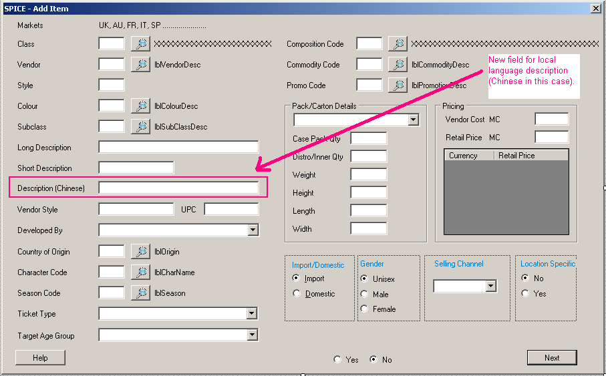

### Change Item screen

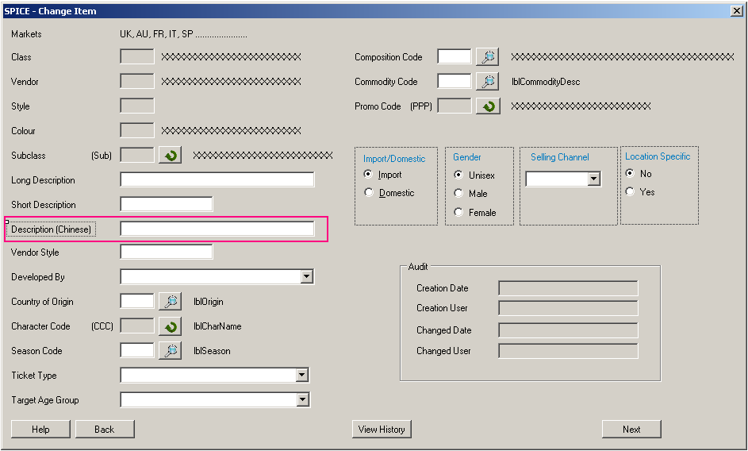

### Add Assorted Pre-Pack (APP) screen

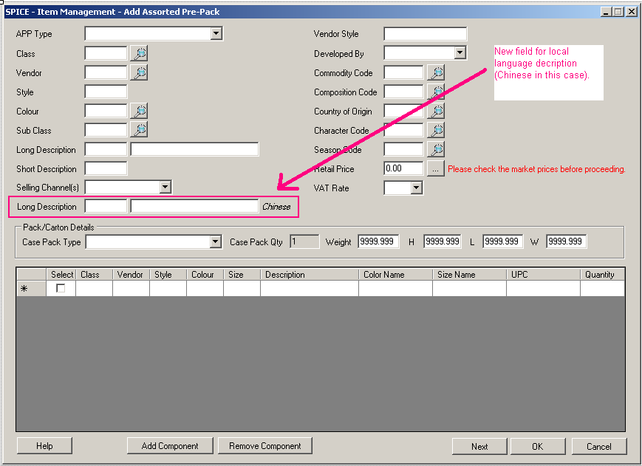

### Change Assorted Pre-Pack (APP) screen

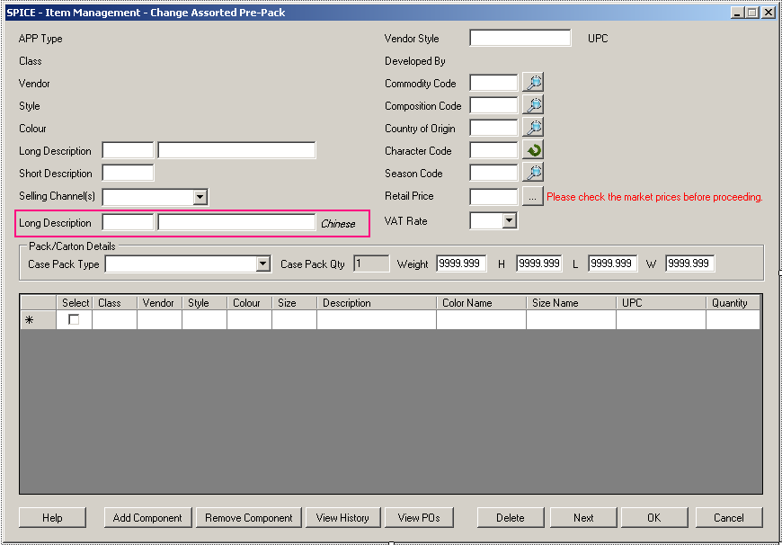

### EAS Approve/Reject screen

